**SOFTWARE REQUIREMENT SPECIFICATION**

**DOCUMENT**

**CALCULATOR SYSTEM**

**Version:** Version 2.0



**ABSTRACT**

This document is intended to be the SRS for develop **CALCULATOR SYSTEM**



| **Project Title** | **CALCULATOR SYSTEM** | | |
| --- | --- | --- | --- |
| **Lead Institution** | **THE INTERNATIONAL SCHOOL - DUY TAN UNIVERSITY** | | |
| **Project Mentor** | **Mr. Nguyen Dang Quang Huy** | | |
| **Team Name** | **Team 8** | | |
| **Team Members** | **Tran Phuoc Khoa** | | |
| **Dang Tuan Minh** | | |
| **Tran Thi Thanh Vinh** | | |
| **Tran Hoai Kien** | | |
|  | | |
| **Start Date** | Jan 20, 2024 | **End Date** | Jan 27, 2024 |

**ROPRIETARY INFORMATION**: The information contained in this document is the property of **TEAM 8**. Except as specifically authorized in writing by **TEAM 8**, the holder of this document shall keep all information contained herein confidential and shall protect same in whole or in part from disclosure and dissemination to all third parties

**Table of Contents**

Revision History 3

1. Introduction 4

1.1. Purpose 4

1.2. Intended Audience and Reading Suggestions 4

1.3. References 4

2. Project Overview 4

2.1. Project Description 4

2.2. Business Need 4

2.3. Project Analyst 4

2.3.1. Business Function Diagram 4

2.3.2. System Context Diagram 5

2.4. Software Requirement Specification 6

2.4.1. High level Functional Requirement (FR) 6

2.4.2. Stakeholders 6

2.4.3. Use case 7

2.4.4. List of use case 7

UC 01: Addition 7

UC.02: Subtraction 9

UC.03: Multiplication 10

UC.04: Division 11

UC.05: Modulus 12

2.4.6 . Activity Diagrams 13

Addition 13

Subtraction 13

Multiplication 14

Division 15

Modulus 15

Appendix A: Glossary 16

# Revision History

| **Date** | **Change Iterm** | **Description** | **by** | **Version** |
| --- | --- | --- | --- | --- |
| **20/1/2024** | Create document, Create BFD |  | Dang Tuan Minh | Version 1.0 |
| 26/1/2024 | Update, Edit | BFD, UC, Activity Diagrams | Tran Thi Thanh Vinh | Version 2.0 |
|  |  |  |  |  |
|  |  |  |  |  |
|  |  |  |  |  |
|  |  |  |  |  |
|  |  |  |  |  |
|  |  |  |  |  |

# Introduction

## Purpose

This documentation describes a Calcuulator System including all needed information and feature materials in detail for implementation. The purposes of this document are as below:

* To supports the project manager having an overview of the system as well as doing project estimation
* To describes the architectural drivers and use cases in details. Based on this document, architect analyst and designer will be able to implement the system easily.
* To supports tester (QC) writing acceptance test and test plan.

## Intended Audience and Reading Suggestions

| **Intended Audience** | **Reading Suggestions** |
| --- | --- |
| Project manager | High level functional requirement, business constraints for estimation |
| Architect analyst and designer | Overall description and user cases to architect and design the system |
| Quality control | Overall description and user cases to make test plan and write acceptance test |
|  |  |

## References

# Project Overview

## Project Description

This document specifies the functional requirements for a scientific calculator program. This program is designed to act like a “handheld calculator” with the usual standard functions (add, subtract, multiply, divide)

## Business Need

## Project Analyst

### Business Function Diagram



### System Context Diagram

## Software Requirement Specification

### High level Functional Requirement (FR)

| **FR.1** | **Title** | **Addition** |
| --- | --- | --- |
| **Stakeholder** | Users |
| **Description** | Perform addition of two numbers entered from the keyboard |
| **FR.2** | **Title** | **Subtraction** |
| **Stakeholder** | Users |
| **Description** | Perform subtraction of two numbers entered from the keyboard |
| **FR.3** | **Title** | **Multiplication** |
| **Stakeholder** | Users |
| **Description** | Perform multiplication of two numbers entered from the keyboard |
| **FR.4** | **Title** | **Division** |
| **Stakeholder** | Users |
| **Description** | Perform division of two numbers entered from the keyboard |
| **FR.5** | **Title** | **Modulus** |
|  | **Stakeholder** | Users |
|  | **Description** | Perform modulus of two numbers entered from the keyboard |

### Stakeholders

| **Stakeholder** | **Description** |
| --- | --- |
| Users | System users |

### Use case

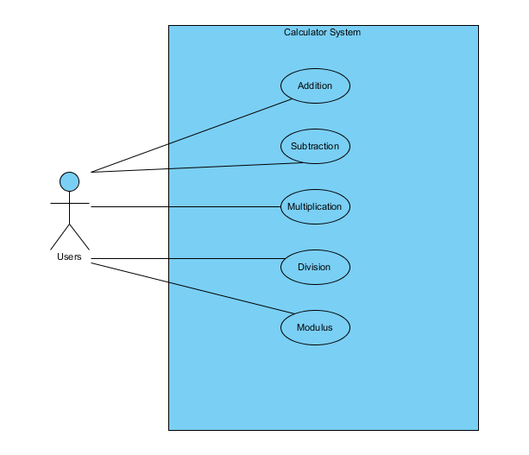

### List of use case

| **Use case ID** | **Use case name** | **Functional Req.** |
| --- | --- | --- |
| UC.01 | Addition | FR.1 |
| UC.02 | Subtraction | FR.2 |
| UC.03 | Multiplication | FR.3 |
| UC.04 | Division | FR.4 |
| UC.05 | Modulus | FR.5 |

**2.4.5.Use Case Specification**

##### UC 01: Addition

1. Use Case Diagram
2. Use Case Specification

| **Use case ID** | UC.01 | | | | |
| --- | --- | --- | --- | --- | --- |
| **Use case name** | Addition | | | | |
| **Create by** | Dang Tuan Minh | | **Last updated by** | | Dang Tuan Minh |
| **Date created** | 22/01/2024 | | **Date last updated** | | 23/01/2024 |
| **Actor** | Users | | | | |
| **Description** | This use case enables users to perform addition calculations between two numbers | | | | |
| **Trigger** | User opens the calculator application | | | | |
| **Pre-condition** | User must select addition from the available operations, which include addition, subtraction, multiplication, and division | | | | |
| **Post-condition** | A user is presented with calculation results if the use case was successful. The system notifies errors if the input is not in the correct format | | | | |
| **Main Success Scenario:** | **Step** | **Actor Action** | | **System Response** | |
| 1 | User click to “+” in a list | | Configure the main form system to align with appropriate mathematical operations | |
| 2 | The user enters the numbers | |  | |
| 3 | User click to “+” button | | The system verifies the result | |
| 4 |  | | The system shows result | |
| **Alternative Scenario** | **Step** | **Actor Action** | | **System Response** | |
| 1 | User click to “+” in a list | | Configure the main form system to align with appropriate mathematical operations | |
| 2 | The user enters the numbers | |  | |
| 3 | User click to “+” button | | The system verifies the result | |
| 4 |  | | The system provides an error message if the input is not in the correct format | |
| **Exception** | **Step** | **Actor Action** | | **System Response** | |
| 1 | User click to “Nhập lại” button | | The system resets the numbers to enter | |
| **Priority** | High | | | | |
| **Business rule** | N/A | | | | |
| **Description:** | After the user opens the calculation app and selects the addition function, the user needs to enter the numbers and calculate. If successful, the calculated number will be displayed otherwise an error will appear | | | | |

1. Prototype

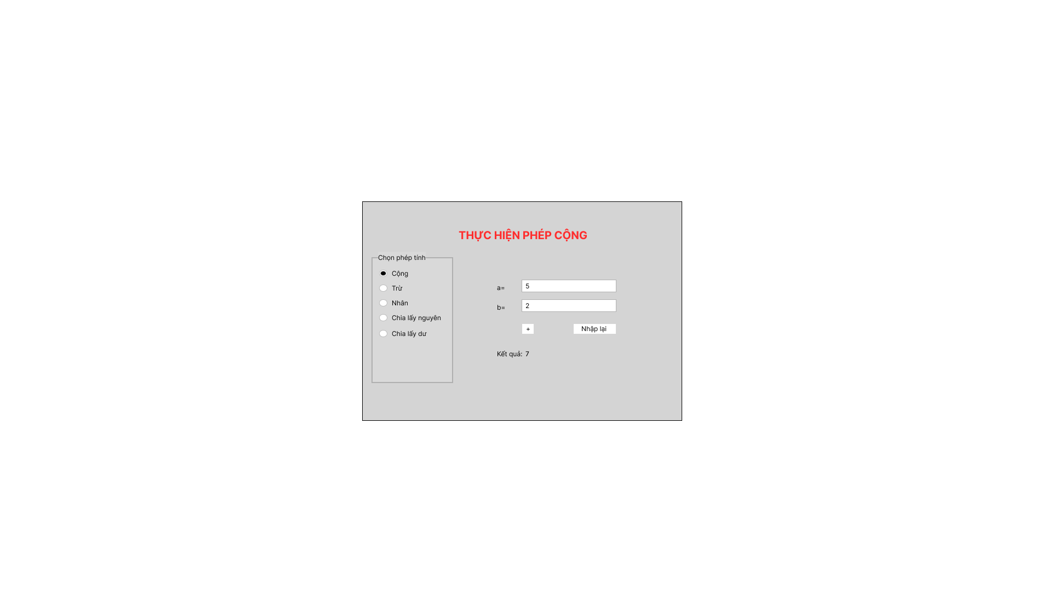

##### UC.02: Subtraction

1. Use Case Diagram
2. Use Case Specification

| **Use case ID** | UC.02 | | | | |
| --- | --- | --- | --- | --- | --- |
| **Use case name** | Subtraction | | | | |
| **Create by** | Tran Hoai Kien | | **Last updated by** | | Tran Phuoc Khoa |
| **Date created** | 22/01/2024 | | **Date last updated** | | 23/01/2024 |
| **Actor** | Users | | | | |
| **Description** | This use case enables users to perform subtraction calculations between two numbers | | | | |
| **Trigger** | User opens the calculator application | | | | |
| **Pre-condition** | User must select Subtracion from the available operations, which include addition, subtraction, multiplication, division and modulus | | | | |
| **Post-condition** | User is presented with calculation results if the use case was successful. The system notifies errors if the input is not in the correct format | | | | |
| **Main Success Scenario:** | **Step** | **Actor Action** | | **System Response** | |
| 1 | User click to “-” in a list | | Configure the main form system to align with appropriate mathematical operations | |
| 2 | The user fill the numbers | |  | |
| 3 | User click to “Calculate” button | | The system verifies the format | |
| 4 |  | | The system shows result | |
| **Alternative Scenario** | **Step** | **Actor Action** | | **System Response** | |
| 1 | User click to “-” in a list | | Configure the main form system to align with appropriate mathematical operations | |
| 2 | The user fill the numbers | |  | |
| 3 | User click to “Calculate” button | | The system verifies the format | |
| 4 |  | | The system provides an error message if the input is not in the correct format | |
| **Exception** | **Step** | **Actor Action** | | **System Response** | |
| 1 | User click to “Nhập lại” button | | The system resets the numbers to enter. | |
| **Priority** | High | | | | |
| **Business rule** | N/A | | | | |
| **Description:** | After the user opens the calculation app and selects the subtraction function, the user needs to enter the numbers and calculate. If successful, the calculated number will be displayed otherwise an error will appear | | | | |

1. Prototype

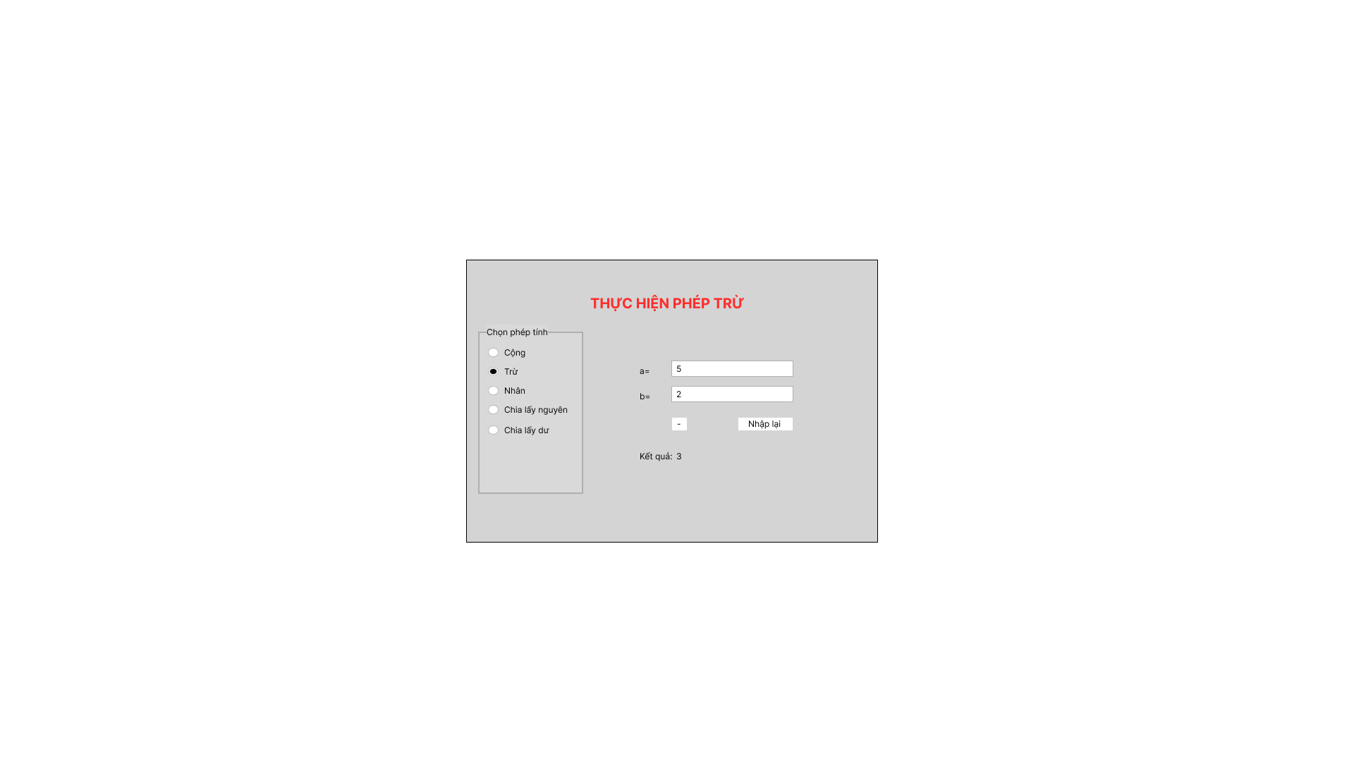

##### UC.03: Multiplication

1. Use Case Diagram
2. Use Case Specification

| **Use case ID** | UC.03 | | | | |
| --- | --- | --- | --- | --- | --- |
| **Use case name** | Multiplication | | | | |
| **Create by** | Tran Hoai Kien | | **Last updated by** | | Tran Phuoc Khoa |
| **Date created** | 22/01/2024 | | **Date last updated** | | 23/01/2024 |
| **Actor** | Users | | | | |
| **Description** | This use case enables users to perform multiplication calculations between two numbers | | | | |
| **Trigger** | User opens the calculator application | | | | |
| **Pre-condition** | User must select Multiplication from the available operations, which include addition, subtraction, multiplication, division and modulus | | | | |
| **Post-condition** | User is presented with calculation results if the use case was successful. The system notifies errors if the input is not in the correct format | | | | |
| **Main Success Scenario:** | **Step** | **Actor Action** | | **System Response** | |
| 1 | User click to “*” in a list | | Configure the main form system to align with appropriate mathematical operations | |
| 2 | The user fill the numbers | |  | |
| 3 | User click to “Calculate” button | | The system verifies the format | |
| 4 |  | | The system shows result | |
| **Alternative Scenario** | **Step** | **Actor Action** | | **System Response** | |
| 1 | User click to “*” in a list | | Configure the main form system to align with appropriate mathematical operations | |
| 2 | The user fill the numbers | |  | |
| 3 | User click to “Calculate” button | | The system verifies the format | |
| 4 |  | | The system provides an error message if the input is not in the correct format | |
| **Exception** | **Step** | **Actor Action** | | **System Response** | |
| 1 | User click to “Nhập lại” button | | The system resets the numbers to enter. | |
| **Priority** | High | | | | |
| **Business rule** | N/A | | | | |
| **Description:** | After the user opens the calculation app and selects the Multiplication function, the user needs to enter the numbers and calculate. If successful, the calculated number will be displayed otherwise an error will appear | | | | |

1. Prototype

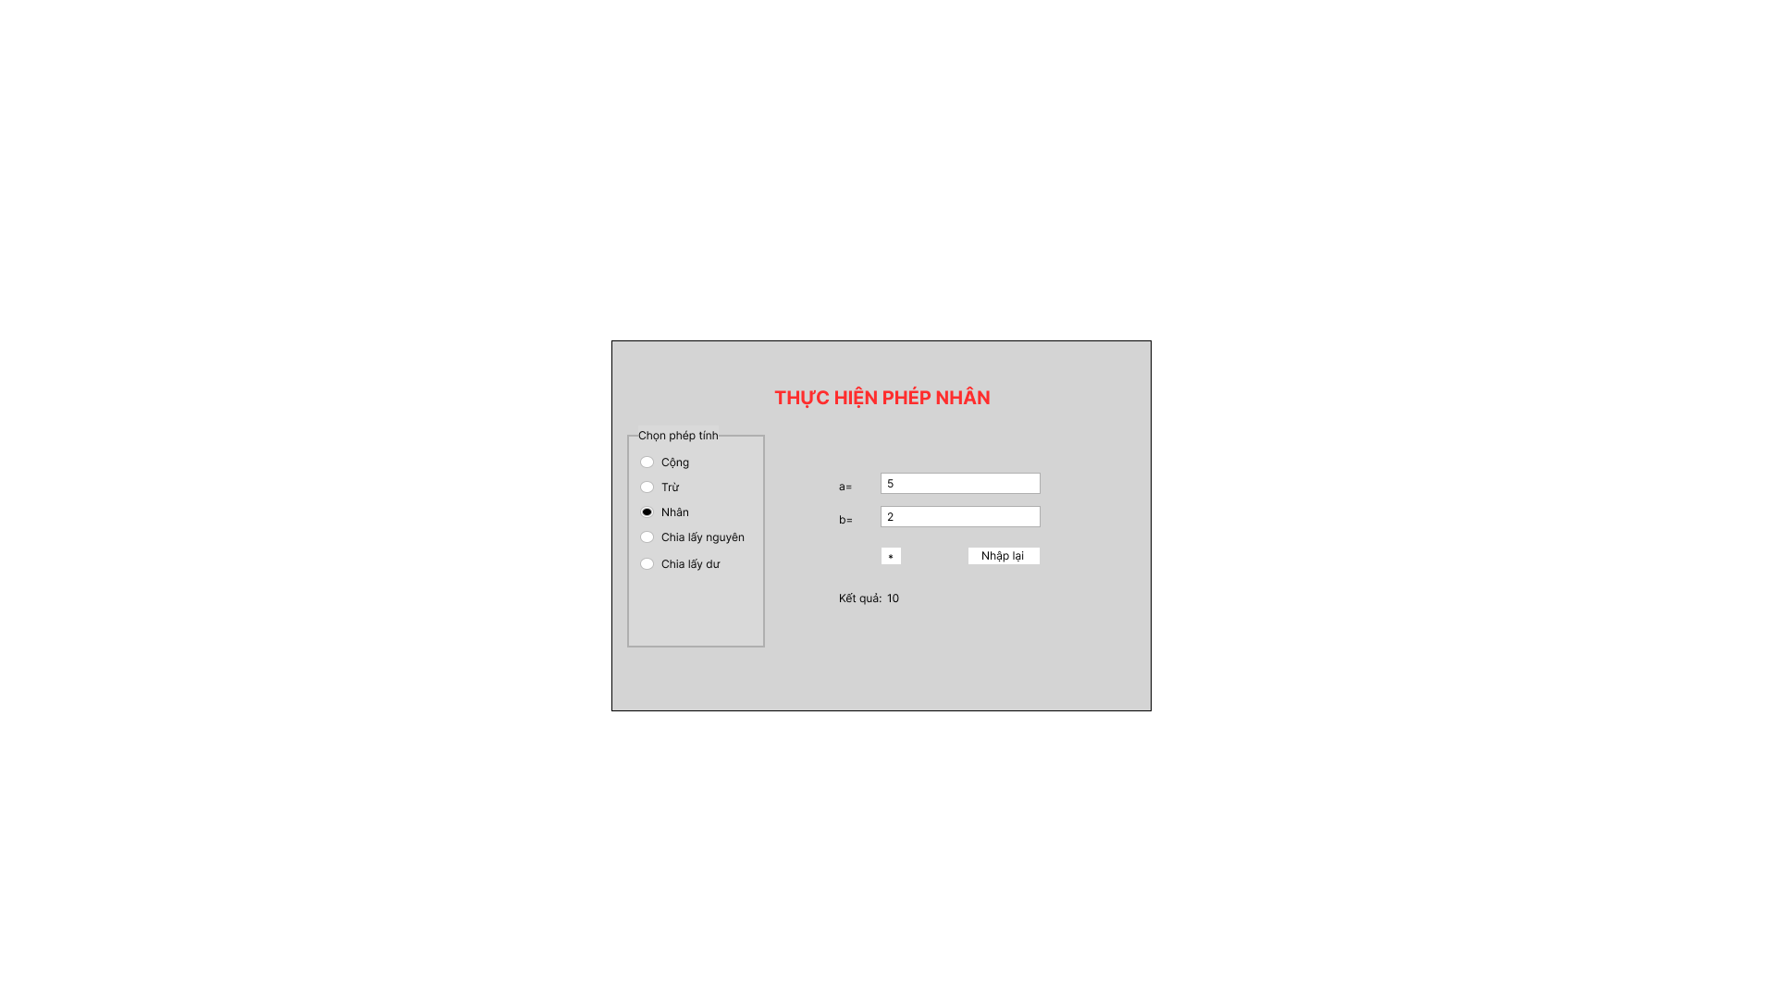

##### 

##### UC.04: Division

1. Use Case Diagram
2. Use Case Specification

| **Use case ID** | UC.04 | | | | |
| --- | --- | --- | --- | --- | --- |
| **Use case name** | Division | | | | |
| **Create by** | Tran Phuoc Khoa | | **Last updated by** | | Tran Phuoc Khoa |
| **Date created** | 22/1/2024 | | **Date last updated** | | 23/1/2024 |
| **Actor** | Users | | | | |
| **Description** | This use case enables users to perform division calculations between two numbers | | | | |
| **Trigger** | User opens the calculator application | | | | |
| **Pre-condition** | User must select Multiplication from the available operations, which include addition, subtraction, multiplication, division and modulus | | | | |
| **Post-condition** | User is presented with calculation results if the use case was successful. The system notifies errors if the input is not in the correct format | | | | |
| **Main Success Scenario:** | **Step** | **Actor Action** | | **System Response** | |
| 1 | User click to “/” in a list | | Configure the main form system to align with appropriate mathematical operations | |
| 2 | The user fill the numbers | |  | |
| 3 | User click to “Calculate” button | | The system verifies the format | |
| 4 |  | | The system shows result | |
| **Alternative Scenario** | **Step** | **Actor Action** | | **System Response** | |
| 1 | User click to “/” in a list | | Configure the main form system to align with appropriate mathematical operations | |
| 2 | The user fill the numbers | |  | |
| 3 | User click to “Calculate” button | | The system verifies the format | |
| 4 |  | | The system provides an error message if the input is not in the correct format | |
| **Exception** | **Step** | **Actor Action** | | **System Response** | |
| 1 | User click to “Nhập lại” button | | The system resets the numbers to enter. | |
| **Priority** | High | | | | |
| **Business rule** | N/A | | | | |
| **Description:** | After the user opens the calculation app and selects the Multiplication function, the user needs to enter the numbers and calculate. If successful, the calculated number will be displayed otherwise an error will appear | | | | |

1. Prototype

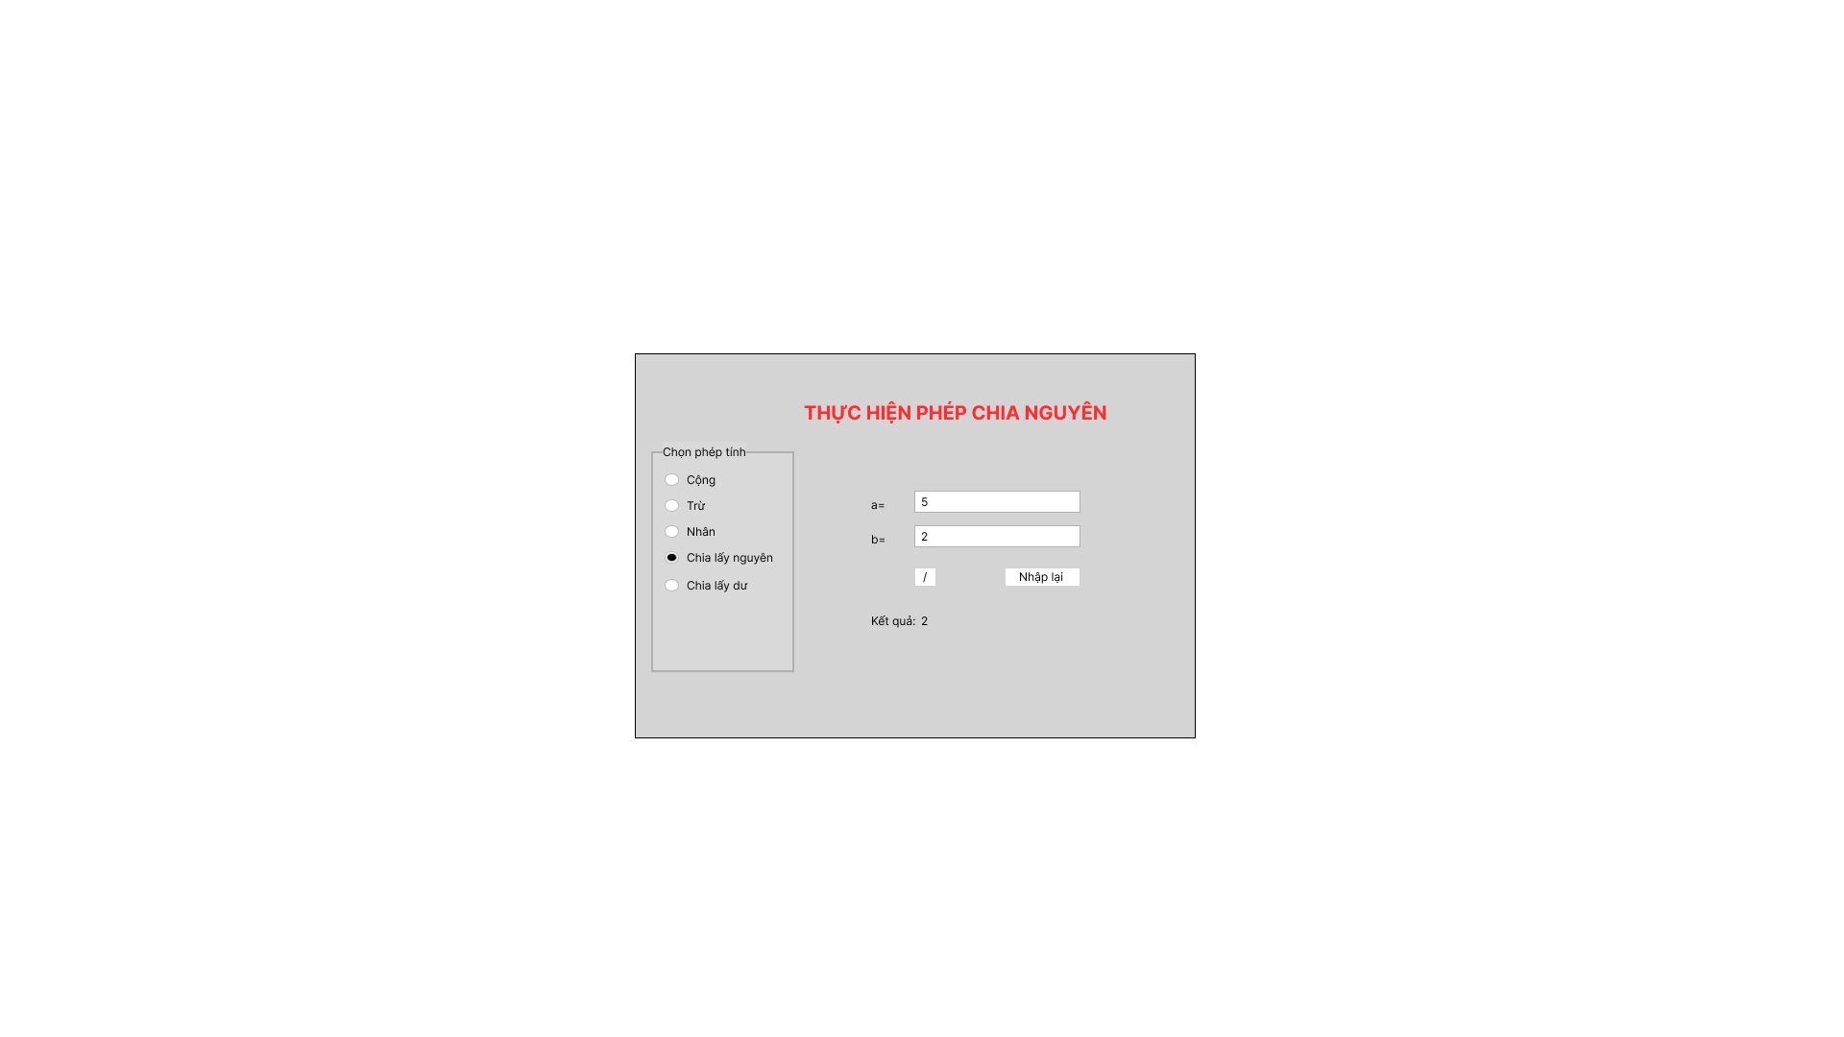

##### UC.05: Modulus

1. Use Case Diagram
2. Use Case Specification

| **Use case ID** | UC.05 | | | | |
| --- | --- | --- | --- | --- | --- |
| **Use case name** | Modulus | | | | |
| **Create by** | Tran Thi Thanh Vinh | | **Last updated by** | | Tran Phuoc Khoa |
| **Date created** | 22/1/2024 | | **Date last updated** | | 23/1/2024 |
| **Actor** | Users | | | | |
| **Description** | This use case enables users to perform modulus calculations between two numbers | | | | |
| **Trigger** | User opens the calculator application | | | | |
| **Pre-condition** | User must select Modulus from the available operations, which include addition, subtraction, multiplication, division and modulus | | | | |
| **Post-condition** | User is presented with calculation results if the use case was successful. The system notifies errors if the input is not in the correct format | | | | |
| **Main Success Scenario:** | **Step** | **Actor Action** | | **System Response** | |
| 1 | User click to “%” in a list | | Configure the main form system to align with appropriate mathematical operations | |
| 2 | The user fill the numbers | |  | |
| 3 | User click to “Calculate” button | | The system verifies the format | |
| 4 |  | | The system shows result | |
| **Alternative Scenario** | **Step** | **Actor Action** | | **System Response** | |
| 1 | User click to “%” in a list | | Configure the main form system to align with appropriate mathematical operations | |
| 2 | The user fill the numbers | |  | |
| 3 | User click to “Calculate” button | | The system verifies the format | |
| 4 |  | | The system provides an error message if the input is not in the correct format | |
| **Exception** | **Step** | **Actor Action** | | **System Response** | |
| 1 | User click to “Nhập lại” button | | The system resets the numbers to enter. | |
| **Priority** | High | | | | |
| **Business rule** | N/A | | | | |
| **Description:** | After the user opens the calculation app and selects the Modulus function, the user needs to enter the numbers and calculate. If successful, the calculated number will be displayed otherwise an error will appear | | | | |

1. Prototype

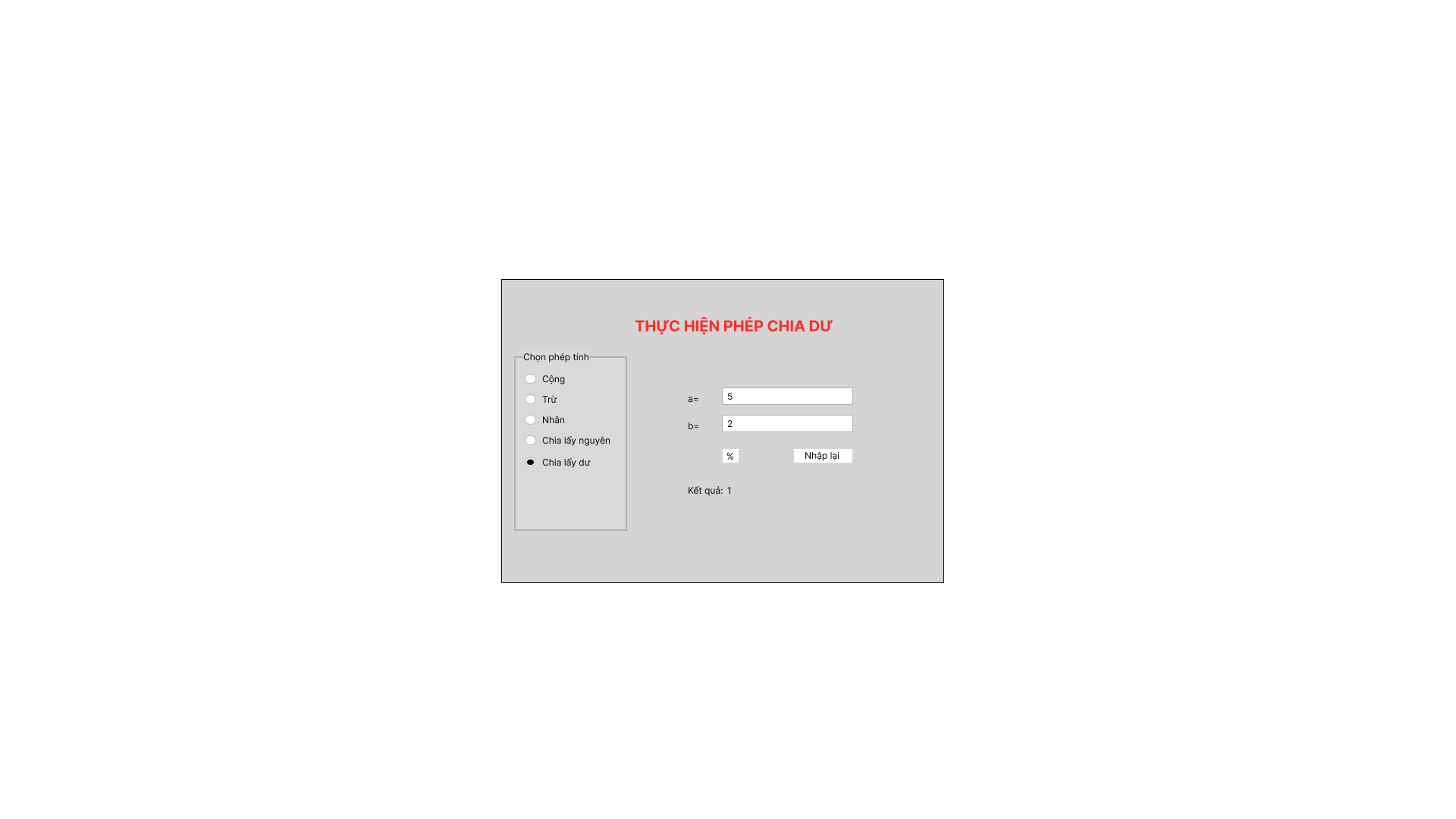

## 2.4.6 . Activity Diagrams

## Addition

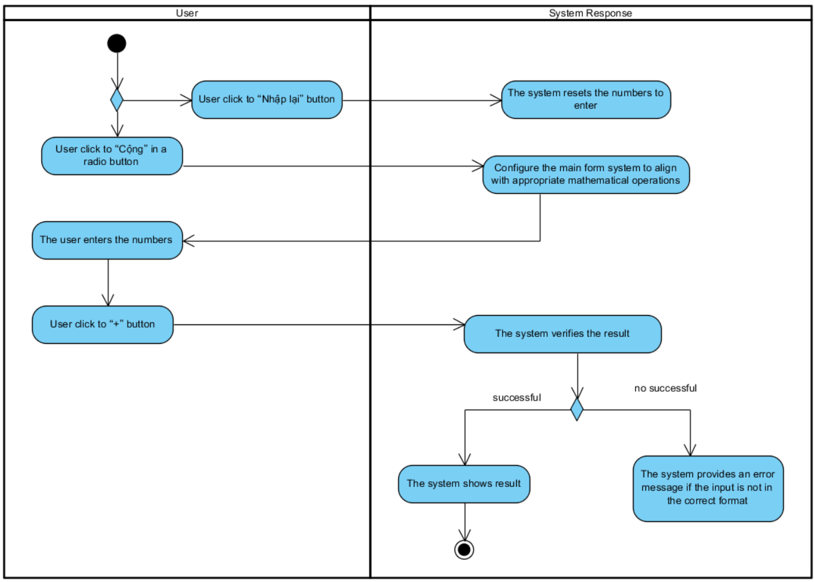

## Subtraction

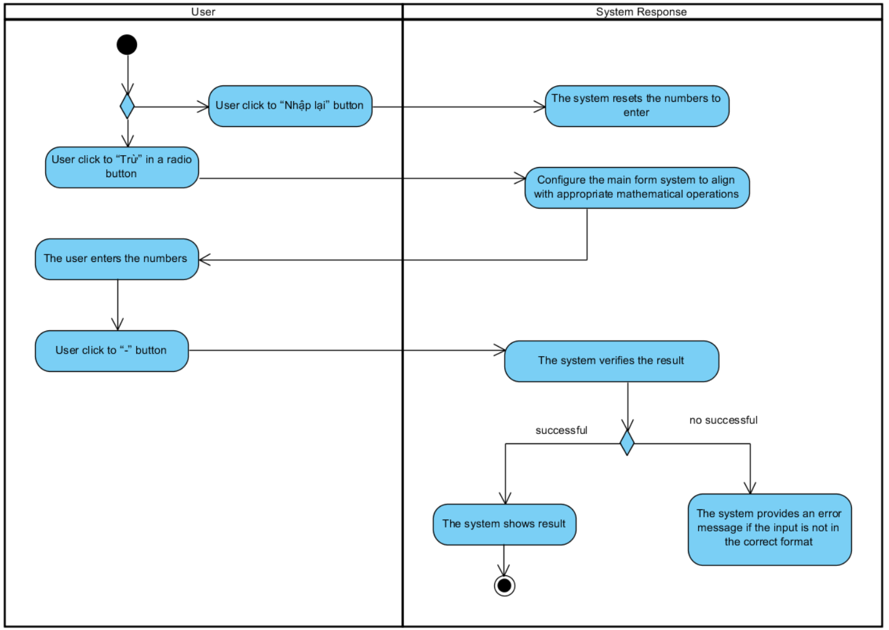

## Multiplication

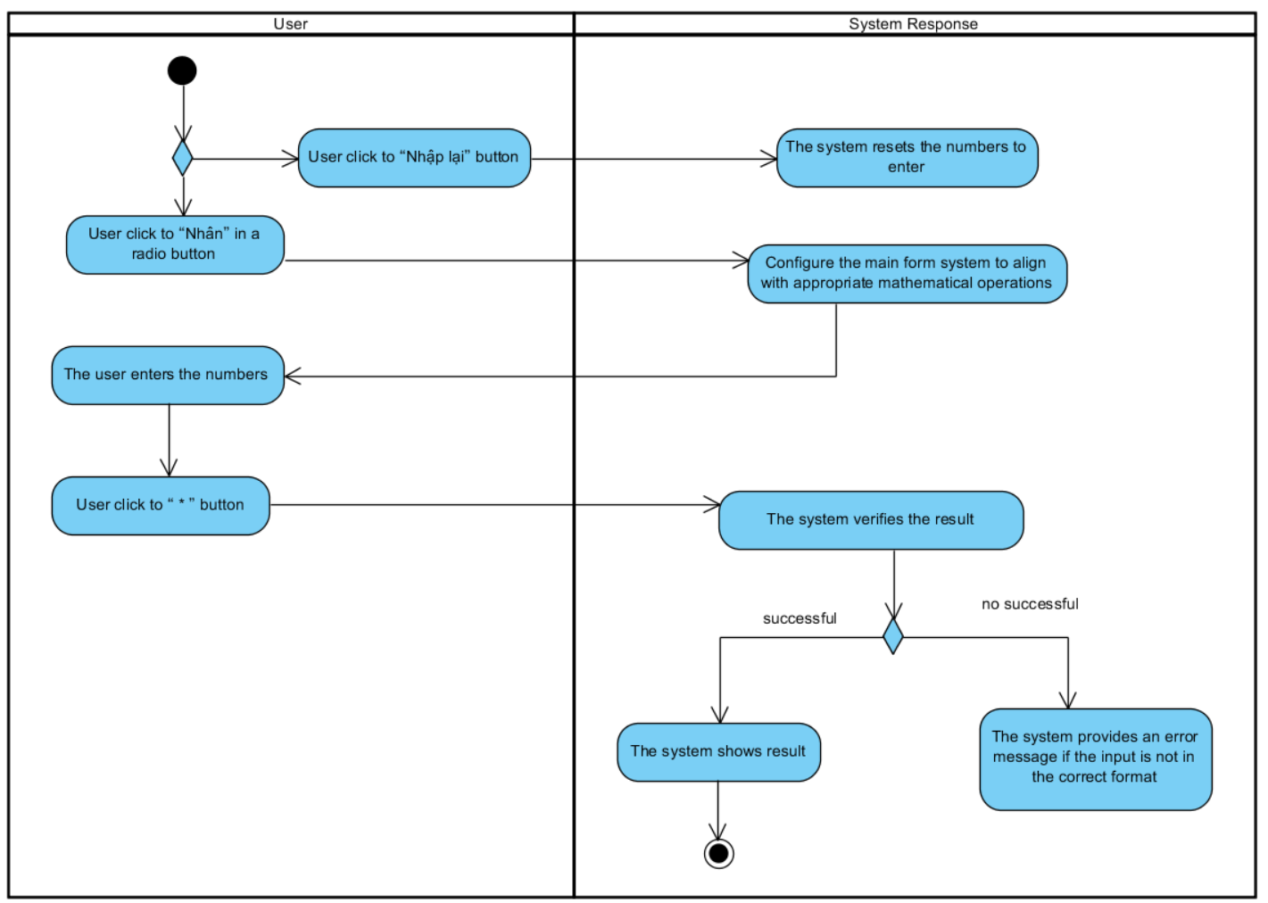

## Division

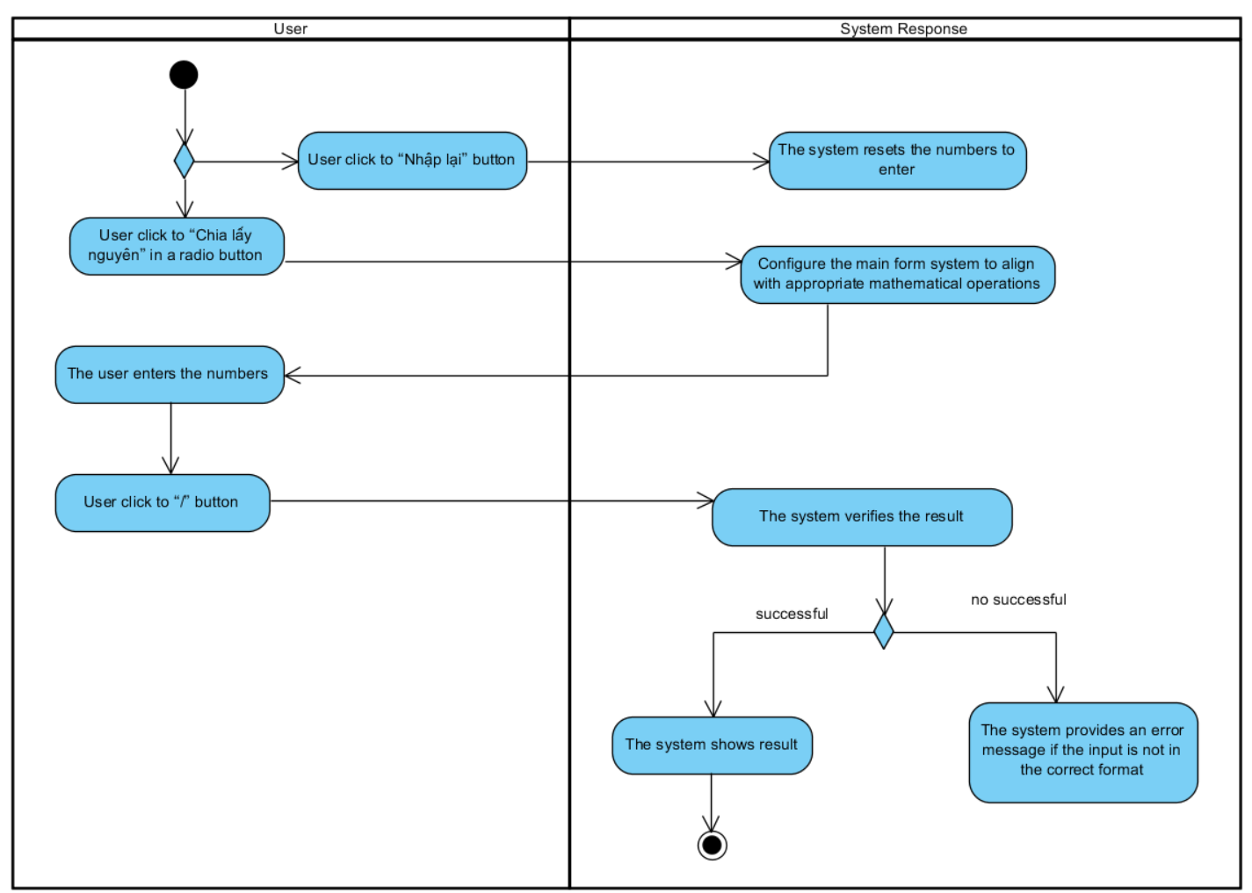

## Modulus

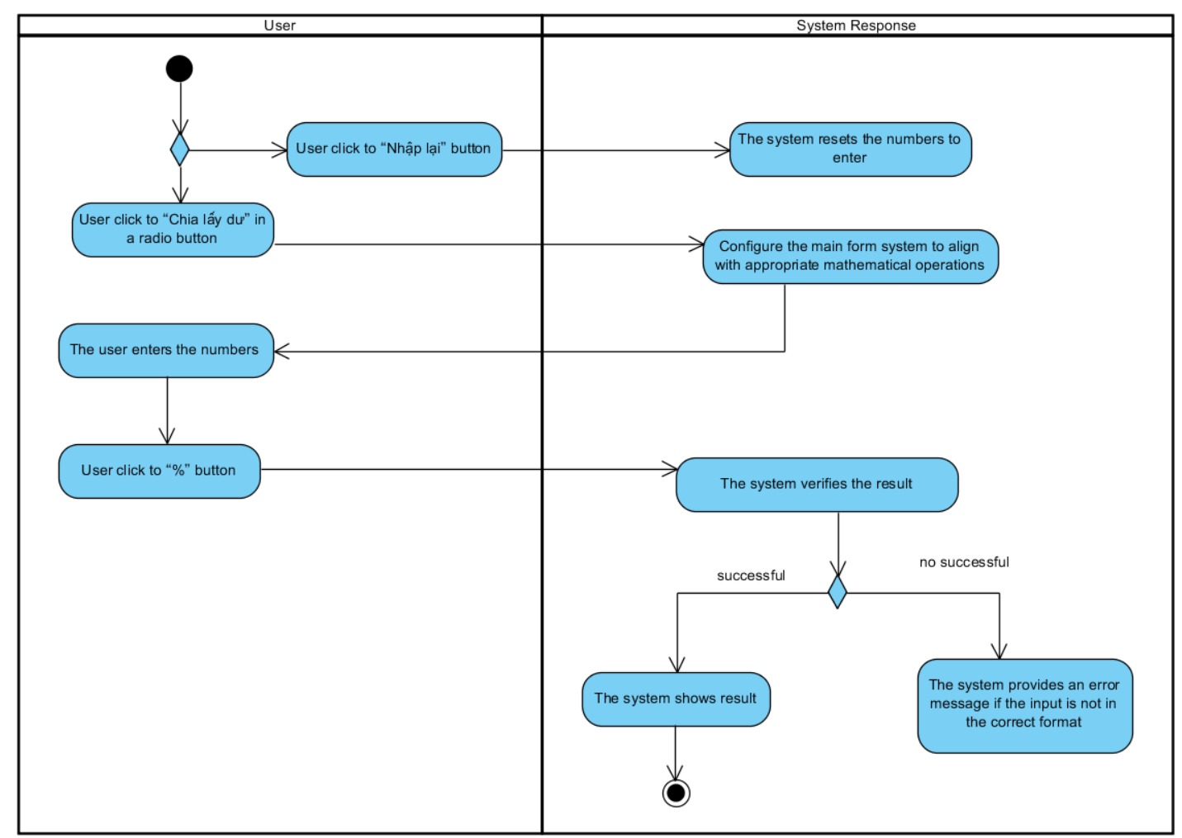

# Appendix A: Glossary

| FR | **Functional Requirement** |
| --- | --- |
| QA | Quality Attribute |
| UC | Use case |
| BR | Business rule |